DNS Forwarder

To get to a website that our DNS does not have a record for.

If you cant get to a website <http://www.cardifforniagurl.co.uk/> you need to add a dns pointer.

Open DNS.

Right click on the DNS server and select properties.

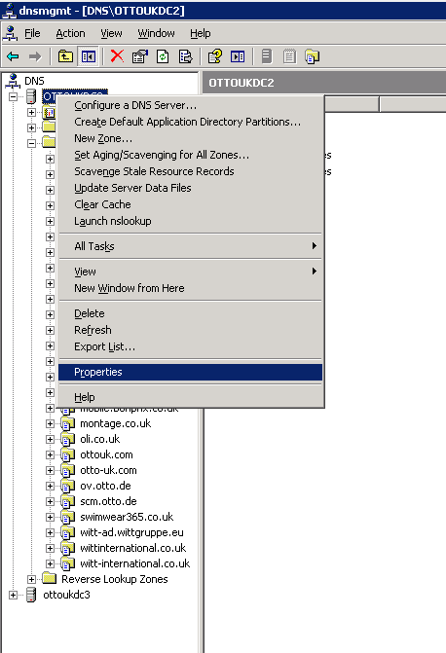

Choose the forwarders tab.

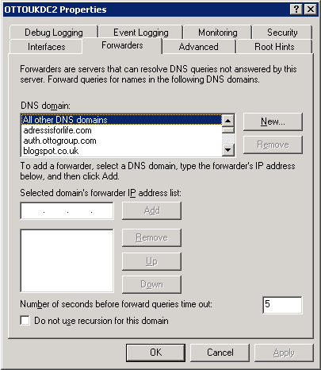

Select new.

Put in the domain of the website…cardifforniagurl.co.uk

Enter the IP address of a DNS server that does have a record. 8.8.8.8 (Google)